Name: Pranav Digambar Kulkarni

Roll No: SYCOA288 Course Name: Project Based Learning - II

Div: A Batch: A4 Course Code: BCE4409

===================================================

**Problem Statement:**

Propose a Conceptual Design using ER features using tools like ERD plus, ER Win etc. (Identifying entities, relationships between entities, attributes, keys, cardinalities, generalization, specialization etc.) Convert the ER diagram into relational tables and normalize Relational data model.

===================================================

**Entity – Relationship Diagram:**

An Entity Relationship (ER) Diagram is a type of flowchart that illustrates how “entities” such as people, objects or concepts relate to each other within a system. ER Diagrams are most often used to design or debug relational databases in the fields of software engineering, business information systems, education and research. Also known as ERDs or ER Models, they use a defined set of symbols such as rectangles, diamonds, ovals and connecting lines to depict the interconnectedness of entities, relationships and their attributes. They mirror grammatical structure, with entities as nouns and relationships as verbs.

**Project Statement:**

This project has been developed with an aim to make the process of printing documents at a xerox centre easier, for both customers and the xerox person. It consists of a user side and a store owner side. The willing users will be able to register themselves on this platform. This project aims at password less login, meaning, the user will receive a link on the provided email ID for verification purpose. After successful registration, verification and login, users will be able to upload the necessary documents for printing. On the admin side, the xerox person will be able to access these uploaded documents during the time of printing. User can set a unique secure pin after creating the account. This ensures complete security of the documents and no unauthorized access can be made. This project has various benefits and one important benefit is security of documents. The communication between the user and admin is very transparent. By using such process for printing of documents, it would become easier for the xerox person and the user to keep a track of their respective records.

Purpose

The purpose of this project is to reduce time and rush that takes place at xerox centres when the documents are printed in the traditional way. Another important purpose is security of user’s documents.

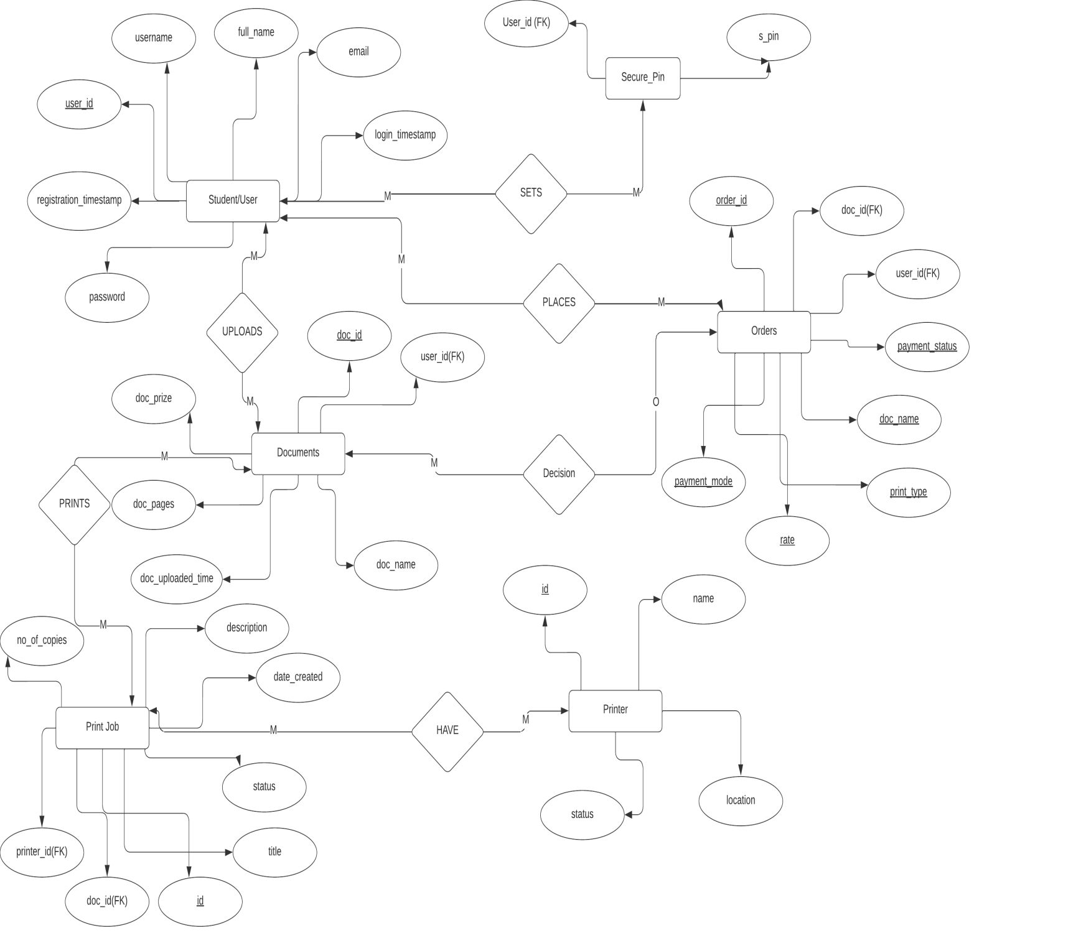

**Reduction of ER Diagram into Tables:**

|  |  |
| --- | --- |
| **Student/User** | |
| User_id (PK) | Number |
| Username | Varchar |
| Fullname | Varchar |
| Email id | Varchar |
| Password | varchar |
| Registration_timestamp | Varchar |
| Login_timestamp | Varchar |

|  |  |
| --- | --- |
| **Secure_pin** | |
| User_id (FK) | **Number** |
| S_pin | **Number** |

|  |  |
| --- | --- |
| **Documents** | |
| doc_id (PK) | **Number** |
| User_id(FK) | **Number** |
| Doc_name | Varchar |
| Doc_uploaded_timestamp | Varchar |
| Doc_prize | Varchar |
| Doc_pages | Varchar |

|  |  |
| --- | --- |
| **Uploads Relationship** | |
| User_id | **Number** |
| Doc_id | **Number** |

|  |  |
| --- | --- |
| **Orders** | |
| order_id (PK) | **Number** |
| User_id(FK) | **Number** |
| Doc_id(FK) | **Number** |
| Payment_status | Varchar |
| Doc_name | Varchar |
| rate | Varchar |
| Payment_mode | Varchar |
| Print_type | Varchar |

|  |  |
| --- | --- |
| **Order place Relationship** | |
| User_id | **Number** |
| order_id | **Number** |

|  |  |
| --- | --- |
| **Print Job** | |
| id (PK) | **Number** |
| print_id(FK) | **Number** |
| Doc_id(FK) | **Number** |
| No_of_copies | Varchar |
| description | Varchar |
| Date_created | Varchar |
| status | Varchar |
| title | Varchar |

|  |  |
| --- | --- |
| **Prints Relationship** | |
| print_id | Varchar |
| doc_id | Varchar |

|  |  |
| --- | --- |
| **Printer** | |
| Id(PK) | Varchar |
| Name | Varchar |
| location | Varchar |
| Status | Varchar |